Subject Area |  | Learning Focus | Useful links (All links are external so please check them carefully before sharing with children )
Writing  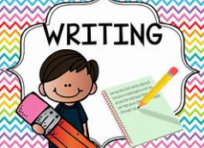 |  | WRITING TO NARRATE: Writing a story from a different perspective. We are focusing on the folk tale of ‘The bananas belong to the monkeys.’  WRITING TO INFORM: A non-chronological report. We are writing a report focussing on the features of a non-fiction text. | https://www.onceuponapicture.co.uk/
Reading  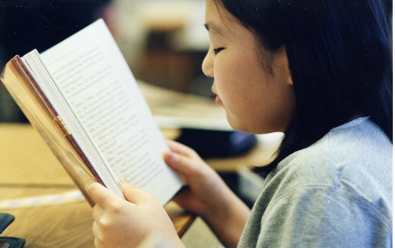 |  | PROSODY: Improving fluency and expression when reading aloud.  VIPERS: Learning key comprehension skills through a variety of texts.  MODELLED READER:  Year full of stories – The bananas belong to the monkeys.  The Creakers. | https://www.storyberries.com/bedtime-stories-the-easter-bunny-school-easter-stories-for-kids/
Maths  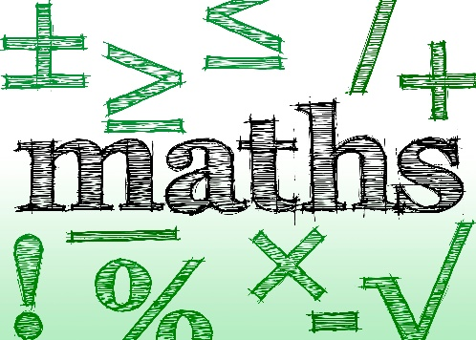 |  | PLACE VALUE: Value of digits up to 10,000, reading and writing numbers in numerals and words.  ADDITION: Mental and written methods for addition.  TIMES TABLES: Increasing fluency and recall for multiplication and division facts. | https://mathsframe.co.uk/en/resources/resource/477/Multiplication-Tables-Check  https://www.timestables.co.uk/
Science  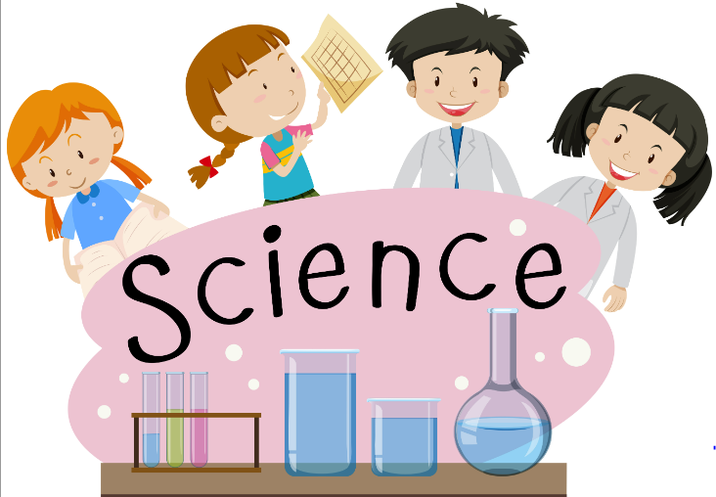 |  | ENNVIRONMENTAL RANGERS: Classification, food chains, habitats and learning about how humans can have a positive and negative influence on our environment. | Year 4: Sound | STEM
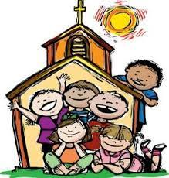  RE |  | CREATION: The story of creation, Abraham and Joseph, Jacob and Joseph from the Old Testament.  JESUS TEACHES US TO PRAY: Looking at prayer through the bible and understanding how Jesus taught us to pray. | https://cafod.org.uk/education/for-families  https://www.loyolapress.com  What is Hinduism? - BBC Bitesize
History  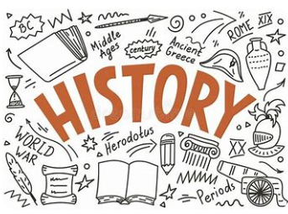 |  | ANGLO-SAXON SETTLERS: Children will learn who the Anglo-Saxons were, when they began to invade Britain and how they settled over time. Children will learn about the society of the Anglo-Saxons and the legacy they left behind. Children will develop their chronological understanding and vocabulary. | BBC - Search results for anglo saxons invade
Music  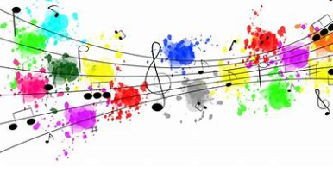 |  | BRASS: Children will continue to learn to play their brass instruments this term.  SINGING: We will continue to develop our singing skills through hymn practice and focusing on modern songs that can be sung in rounds. | https://www.daspmusic.co.uk/ks2-10-15-min-sings.html
ART/D&T  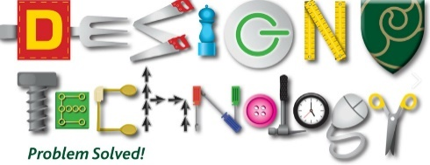   |  | FABRIC OF NATURE: Taking inspiration from the rainforest to create drawings from selected images using chalks and pastels. Creating mood boards inspired by their drawings. Explore and understand the work of artists inspired by the world around us.  D&T: Explore how fastening can be used in design and create a book sleeve with a fastening.

