Subject Area |  | Learning Focus | Useful links (All links are external so please check them carefully before sharing with children )
Writing  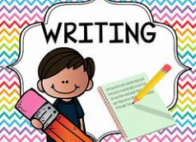 |  | Narrative poetry- The Listeners by Walter De La Mere. Writing to narrate Suspense story based on the poem.  Real Experience Videos / interview linked to climate change. Writing to explain Explanation text linked to climate change.  The Listeners- Respond in writing to a Poem by Walter De la Mere | https://www.bbc.co.uk/bitesize/topics/zpccwmn  https://www.literacyshed.com/
Reading  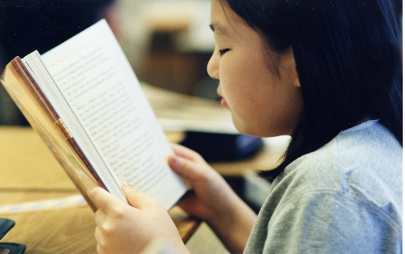 |  | Through a range of reading materials, children consolidate their comprehension skills. | https://www.bbc.co.uk/bitesize/topics/zs44jxs  https://www.literacyshed.com/
Maths  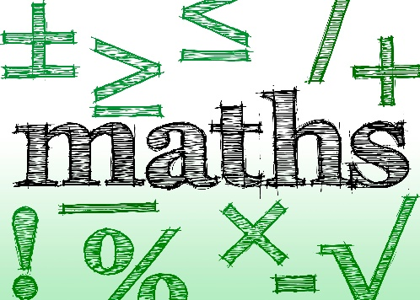 |  | Consolidate the 4 operations to include word problems.  Learn equivalence in fractions and be able to compare fractions using equivalence. Learn to use all 4 operations with fractions including using mixed number fractions and improper fractions. Link fractions to percentages and calculate percentages of an amount. Link fractions and percentages to their corresponding decimal.  Link fractions to ratio and calculate through word problems.  Start algebra using symbols and letters in place of numbers. Learn some algebraic rules and use algebra to solve problems including substitution. | https://www.mymaths.co.uk/  https://thirdspacelearning.com/primary-resources/  https://www.ncetm.org.uk/
Science   |  | Our Science unit this half term is called ‘It’s Electric’. The children will be learning to associate the brightness of a lamp or the volume of a buzzer with the number and voltage of cells used in the circuit, compare and give reasons for variations in how components function, including the brightness of bulbs, the loudness of buzzers and the on/off position of switches and use recognised symbols when representing a simple circuit in a diagram. | Circuit Construction Kit: DC - Series Circuit | Parallel Circuit | Ohm's Law - PhET Interactive Simulations  Electricity - KS2 Science - BBC Bitesize
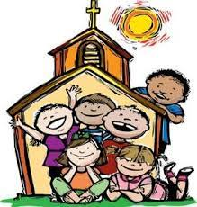  RE |  | Belonging to the Church Community-  Know that a direct link exists between the teachings of the Apostles, the role of the Pope and Bishops today and the faith that is nourished and celebrated in the local parish community today.  Advent- Know that there are 2 parts to the Season of Advent. Know why it is important for Christians to prepare for Advent. Write a hymn about Christ coming into the world and modern parables. Know that Christians keep watch and are waiting on Christ to come again. | https://cafod.org.uk/education/primary-teaching-resources/advent-calendar-for-children  https://missiontogether.org.uk/calendar/advent-resources/
History  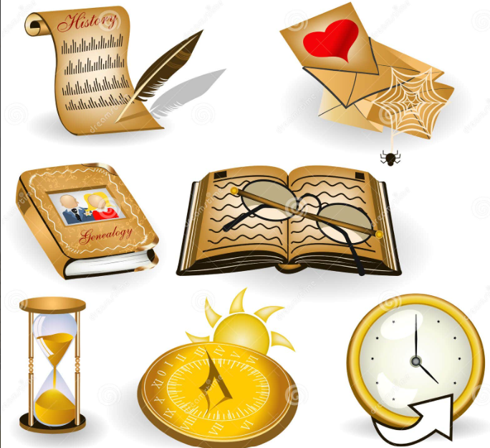 |  | - When and how did World War II break out?  - Who were the Allied and Axis powers?  - What happened during the Birmingham Blitz?  - How did World War II impact everyday life?  - How did the role of women change during World War II?  - Why was Winston Churchill significant?  - What is the legacy of World War II? | https://www.natgeokids.com/uk/discover/history/general-history/world-war-two/  https://www.bbc.co.uk/teach/class-clips-video/articles/zjnyscw
Computing   |  | - Explain that codes can be used for a number of different reasons and decode messages.  - Explain how to ensure a password is secure and how this works.  - Explain the importance of historical figures and their contribution towards computer science.  - Present information about their historical figures in an interesting and engaging manner.  - Develop an idea for a computer of the future and create a simple design.  - Produce a simple audio advert with simple edits, which demonstrate an understanding of how to use the software. | https://www.bbc.co.uk/bitesize/subjects/zvnrq6f  https://www.stem.org.uk/primary/resources/collections/co
ART/D&T     |  | - Select relevant images and cut them with confidence and a level of control.  - Use recording devices and available software with confidence.  - Demonstrate a confident understanding of Edward Weston’s style through their artistic choices.  - Select a suitable range of props, considering the design brief and their initial ideas.  - Use the viewfinder to set up an effective composition, thinking about the scale and positioning of objects.  - Use editing software to change their image, reflecting an artist’s style.  - Choose a suitable painting and suggest appropriate ways to recreate it photographically with props.  - Set up a composition and think about a space that will provide good lighting levels.  - Create a final painting or drawing with tonal differences that create a photo-realistic effect.
PE   |  | Gymnastics  The children will develop their straddle, forward and backwards rolls and put these into a sequence. They will use counterbalance and counter tension in routines and they will develop their jumps and explore the effects of height and they will safely travel over and across apparatus.  Fitness  The children will take part in a range of activities that explore and develop different areas of their health and fitness. They will increase their speed and stamina, develop their strength using their own body weight, they will develop their agility and coordination and develop their balance skills with increasing control.

