Music Development Plan for Our Lady of the Wayside School
School: Our Lady of the Wayside School
Local music hub:
Music lead: Miss Stanton Music specialist (if applicable): Mrs Donohoe and Mrs Vinti Headteacher: Mrs Enstone
Date written: 5.12.25 Review date: June 2026
1 – Overall objective/ vision | The overall objective is to provide a rich, diverse, and progressive music curriculum for all children (including during school hours and before/after school). This will be delivered through outstanding music teaching and leadership.  Opportunities to learn musical instruments and sing as part of a choir, participating and performing regularly in both whole class and extra curricular ensembles, both in and out of school will showcase our children and make our school a leader in music education within the local community and beyond. This will also maximise cultural capital for all our children, their overall wellbeing and confidence, while creating a supportive community of music making.
2 – Key components | The Key components to our successful music provision are:  One hour of Music teaching per week per class.  A progressive programme of whole class instrumental specialist delivery from year 1 to 6.  1-1 teaching from visiting music teachers  Links with external music organisations and the newly formed Solihull / Warwick / Coventry combined music hub.  Pupil Premium student engagement  Succession planning and CPD  Choirs  Whole school singing assemblies  Performance opportunities both within and outside of school.  Funding & Staffing
3 – Classroom instrumental teaching | Year 1 and 2: 1 term of whole class glockenspiel delivered by a music specialist. This is linked to the Get Set 4 Music curriculum delivered by class teachers during the rest of the year.  Year 3: 1 term of whole class recorder delivered by a music specialist progressively transferring and building upon skills from glockenspiel to a wind instrument and linked to the Get Set 4 Music curriculum delivered by class teachers during the rest of the year.  Year 4: 1 term of djembe drums delivered by specialist teacher Sam Donohoe.  Year 5: 1 term of ukulele delivered by a music specialist progressively transferring and building upon both musical and ensemble skills and incorporating small group composition and linked to the Get Set 4 Music curriculum delivered by class teachers during the rest of the year.  Year 6: 1 term of Samba delivered by a music specialist progressively transferring and building upon skills learnt in previous year groups.  All instruments for whole class delivery are owned by the school.  .
4 – Implementation of key components | The whole school follows the Get Set 4 Music scheme, which is very comprehensive and teacher friendly.  This is the schedule across the school.  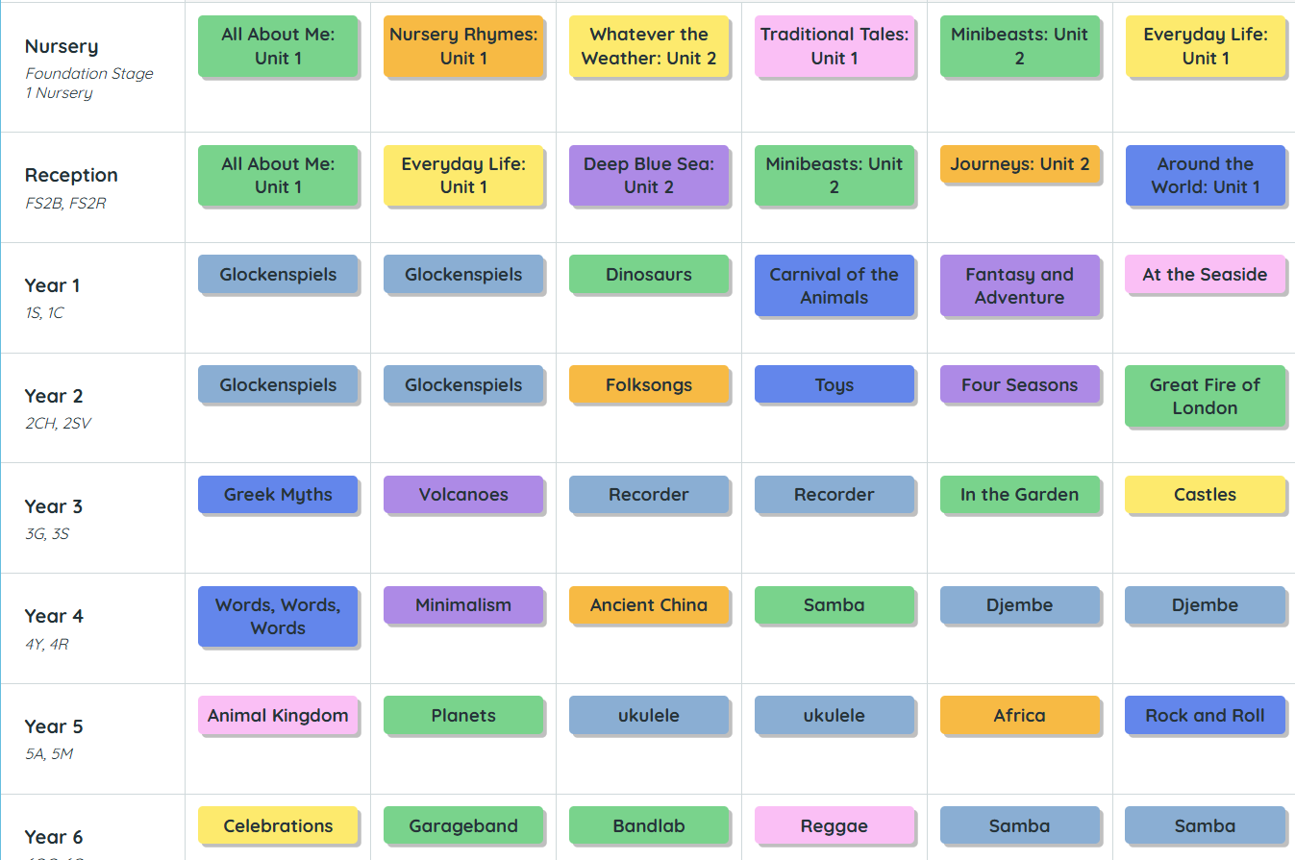  An example of one unit from Year 3. Volcanoes.  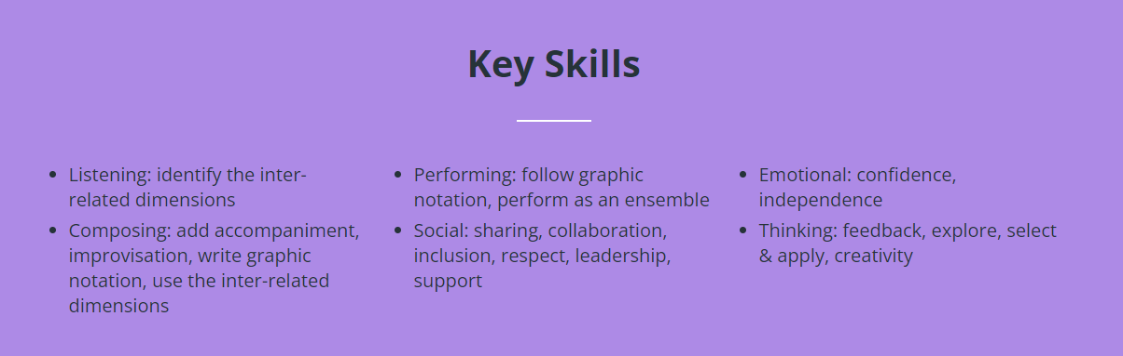  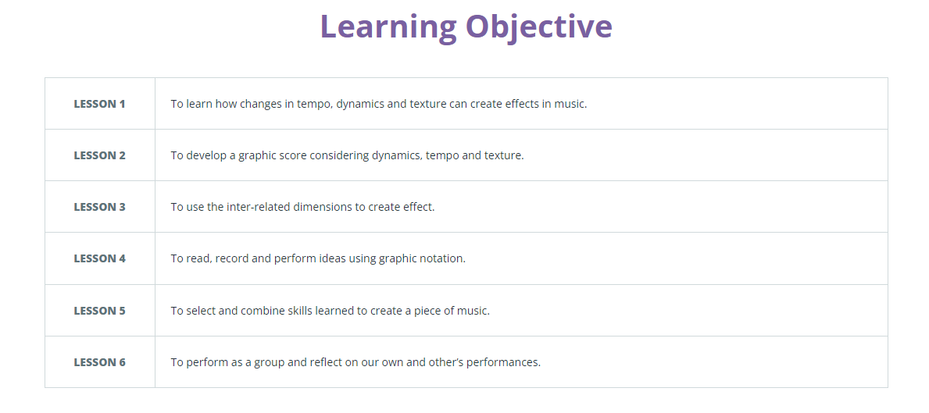  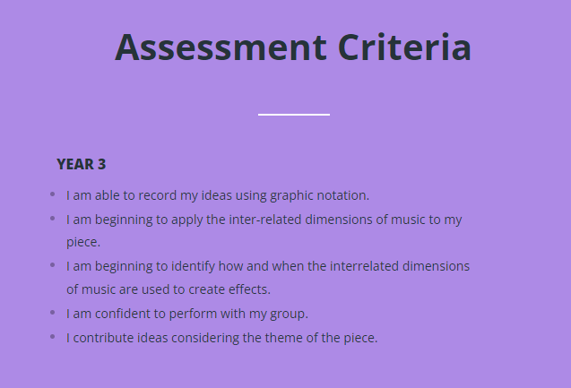  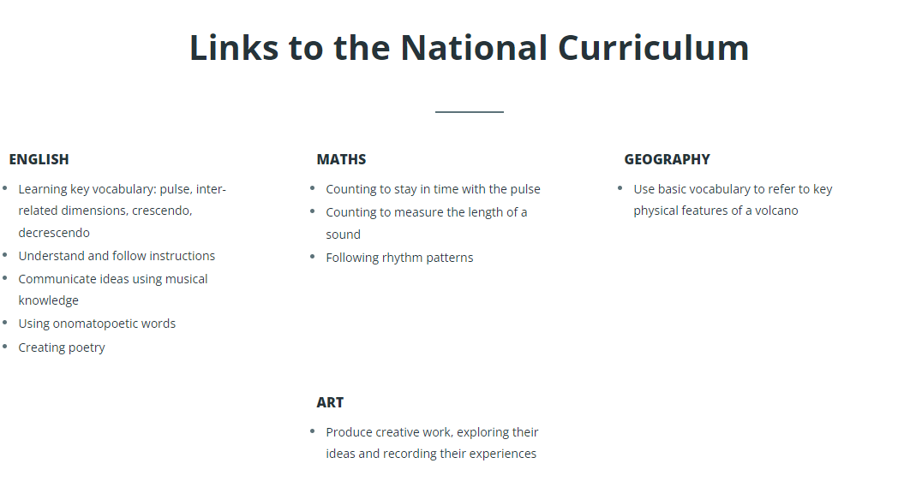  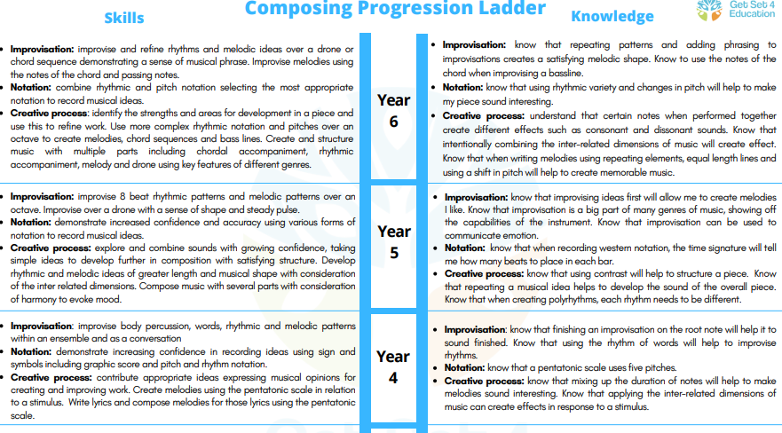  There are progression documents like this one that run from EYFS to Year 6. They are also in this format for Listening and Performing. This clearly shows the progression steps from one year group to the next.  One of the lesson slides complete with music that the children can listen to.  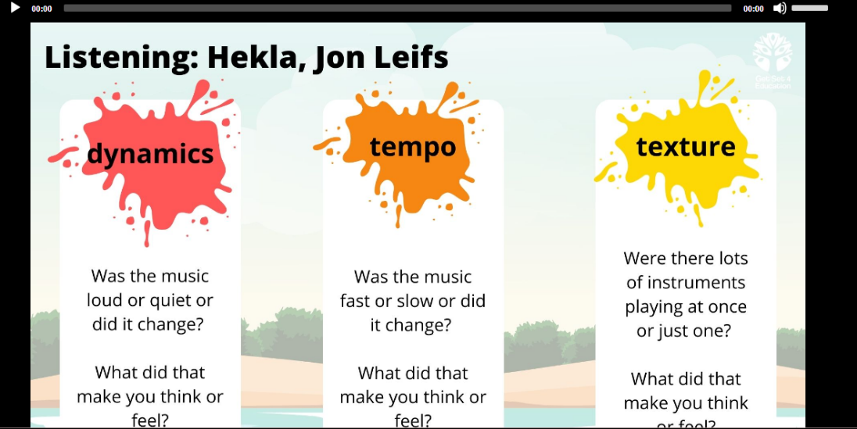  Music curriculum – EYFS, KS1, KS2, SEND. Listening curriculum and school song bank.  Classroom instrumental teaching in each class termly.  Visiting music teachers – work with music service  Links with external music organisations – to support recruitment of children for instrumental and before/after school activities, alongside inspiring future musicians and opportunity to see a live concert.  Succession planning and CPD – Increase capacity of music delivery beyond the music lead/specialist.  Choir/ensemble – launch a KS2 choir/ continuer instrumental ensemble for pupils  Whole school singing assemblies – provide a weekly whole school singing assembly. Repertoire – refers to Model Music Curriculum songs and listening suggestions. Performance opportunities –We provide a range of performance opportunities for children in school and beyond for parents to attend: Carol Concert, Choral Festival. We have class music assemblies for parents showcasing music curriculum music; nativities and class/key stage production. We are looking to have a School orchestra/ ensemble – build uptake of instruments to work towards a school orchestra. Attempt a music ensemble paid for by children to be run by a visiting music teacher. Musical engagement with feeder secondary schools –We are looking for opportunities to work with feeder secondary schools for transition.  We are looking into additional funding from hub/charities/fundraising – proactively try to find additional funding for music (e.g. PTA; local charities; fundraising in school from performances etc)
5 – Communication activities | Communication with parents would take place via ParentPay, newsletters, Twitter and the school website.  Our Lady of the Wayside School provides:  A designated team who ensure all children receive an enriched music education.  A specialist teacher who delivers music for at least a term, in each year group.  The Get Set 4 Music Scheme, which is followed from Nursery all the way to Year 6. It is a comprehensive scheme that includes bright and cheerful teaching slides and lesson plans that really engage the children in their learning journey.  A choir (Year 4 to Year 6) practice takes place at 8:30 once a week before school.  Specialist music teachers teach lessons on a whole range of instruments, including djembe drums, recorders, glockenspiels and ukulele.  After each unit is completed, there is a performance in the church or school hall for the parents and the other children to enjoy. These performances are tweeted and kept in the scheme assessments for each child.
6 – Evaluation process for the success of the Music Development Plan | There will be termly progress meetings with the headteacher, the subject lead and the specialist teachers, Mrs Donohoe and Mrs Vinti.
7 – Transition work with local secondary schools | Consider what you will do to maintain musical engagement from Year 6 to Year 7, including any communication you will make with local secondary schools.  We will make contact with local secondary schools (Music Hub can help create links) for a conversation about transition arrangements for this academic year. We have a summary document of all children currently having instrumental lessons, singing in choir, or attending ensembles ready for this meeting….  We are also going to liaise with Secondary school Head of Department regarding the Y7 expected level of musical knowledge and understanding.
8 – Budget materials and staffing | Include details of budget for curriculum music staff, classroom instrumental teaching, enrichment activities, instruments and resources, and subscriptions. Consider how PPA time might be used. Plan CPD.  The budget this year is £300. We also subscribe to the GETSET 4 Music scheme.  We have been successful in our bid for new drums and specialist teaching in drums from SYMSA Grants awards Solihull. This amounts to £1551.86 to include a set of drums and 12 weeks of tutoring.
9 – Pupil Premium and SEND provision | Pupil Premium children will have access to all clubs.  SEND - The music provision is easily accessed by all children. A teaching assistant in each lesson will ensure those who struggle will be given extra guidance.
10 – Summary Action Plan | Write a list of immediate actions – make them SMART (specific, measurable, achievable, relevant, time-bound).  - Contact local hub to for support - ask about instrumental teachers  - Contact head teacher to arrange meeting to discuss budgets in the next month.  - Research CPD and book for next term.  - Organise an ensemble for children to attend after school using instruments.
Useful links The power of music to change lives: a national plan for music education
MT’s national plan coverage
Building a musical culture in a primary school – the nuts and bolts for success

