Our Lady of the Wayside Catholic Primary School – Handwriting (EYFS to Year 6)

Intent
- To ensure that all pupils, including those with SEND and disadvantaged backgrounds, develop handwriting that is legible, fluent and joined.
- To help children communicate effectively through clear, confident written presentation.
- To promote high expectations and pride in all written work.
- To enable pupils to write with increasing speed and stamina while maintaining legibility.
- To provide a consistent, developmental approach to handwriting from EYFS to Year 6, ensuring every child is supported to achieve their personal best.
- To remove barriers to writing by providing targeted intervention and adaptive resources for children with additional needs.

Implementation
Teaching Sequence
At Our Lady of the Wayside, handwriting is taught explicitly, modelled consistently and practised regularly through a clear progression:
- Gross and fine motor skills (supporting the ‘P checks’)
- Accurate letter formation (shape, spacing, sitting on the line, letter size, string)
- Fluency and stamina (slant, speed and style)
Letter Families
Letters are introduced systematically in the following order:
- Ladder Letters Family: l, t, i, j, u, y
- Curly Letter Family: c, o, a, d, g, q, s, f, e
- Bouncy Letters Family: r, n, m, h, b, p
- Zigzag Letters Family: v, w, z, x, k
- Capital Letters Family: A–Z
- Digit Family: 0–9
Joins
The four main joins and examples are:
- Diagonal joins to letters without ascenders: ai, ar, un, am, ear, aw, ir, hu, ti, ki
- Diagonal joins to letters with ascenders: ab, ul, it, ib, if, ub, th, ck, ch, ft, fl
- Horizontal joins to letters without ascenders: ou, vi, wi, op, ow, ov, ri, ru, ve, we, re
- Horizontal joins to letters with ascenders: ob, ol, wh, it, of, rt, rk
Links to Phonics and Spelling
- Handwriting is aligned with Little Wandle Letters and Sounds to ensure consistency between reading, phonics and writing.
- Each grapheme is introduced using its mnemonic and formation phrase to reinforce the link between sound and symbol.
- Weekly handwriting sessions mirror spelling focuses and join types so that learning is fully integrated.
- Teachers provide additional scaffolding and multisensory activities for SEND and disadvantaged pupils to support access and retention.
Development of Tripod Grip
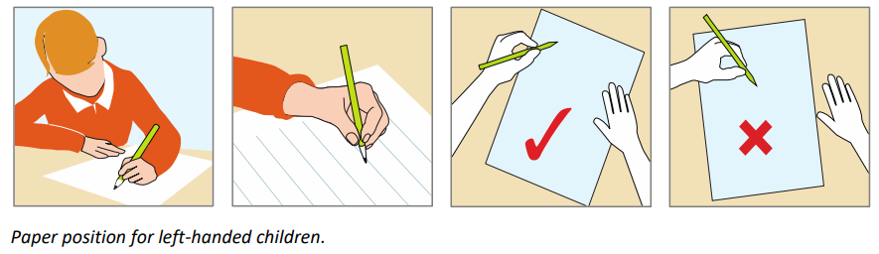
- Pupils are taught to use a tripod grip for control and comfort.
- Teachers model grip and position regularly and correct misconceptions promptly.
- Adaptations such as triangular pencils, pencil grips or sloping boards are used where appropriate to support children with additional fine motor needs.
Handwriting Position and Posture
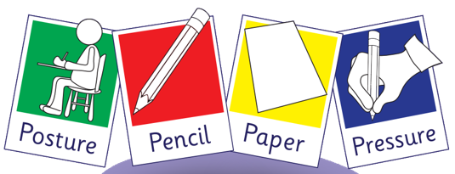
- Pupils sit upright with feet flat on the floor, chair tucked in and back straight.
- Right-handed pupils tilt their paper slightly left.
- Left-handed pupils tilt their paper slightly right to improve visibility and reduce smudging.
- The paper is steadied with the free hand.
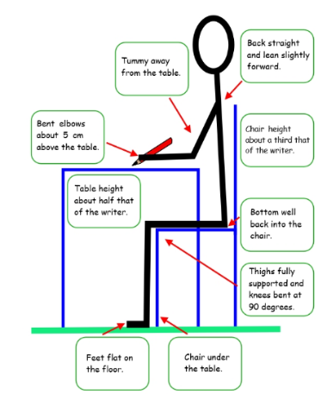
- All children, including those with physical or motor challenges, receive tailored guidance to achieve a comfortable and sustainable position.

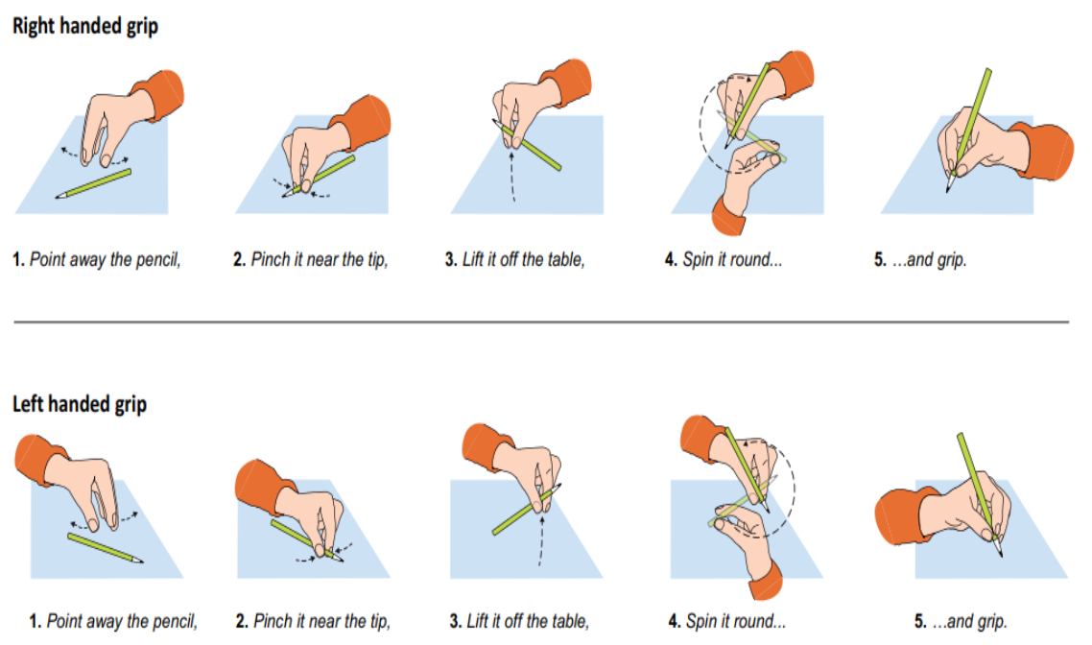

Progression Overview Table
Phase/Year | Focus | Key Learning | Frequency & Approach
EYFS | Letter formation through play and phonics | - Develop fine and gross motor control  - Use Little Wandle formation phrases  - Form lower and capital letters correctly  - Develop tripod grasp and correct posture | - Daily mark-making  - Direct teaching of handwriting  - Continuous provision with targeted support for SEND and disadvantaged pupils
Year 1 | Accurate letter formation | - Secure lowercase and capital letters  - Form digits 0–9  - Understand letter families  - Develop correct pencil grip and posture | - Daily 10-minute sessions  - Individualised feedback and support where needed
Year 2 | Begin joining | - Recap letter families  - Introduce diagonal and horizontal joins  - Identify letters that remain unjoined  - Ensure consistent size and spacing | - Three sessions weekly (15 mins)  - Immediate feedback and support for fine motor development
Years 3–4 | Fluent joining and legibility | - Secure joins and develop consistent slant  - Maintain parallel downstrokes  - Build fluency and rhythm  - Link joins to spelling patterns | - Weekly discrete handwriting  - Two shorter practice sessions  - Scaffolding for pupils needing motor or spatial support
Years 5–6 | Fluent, joined and efficient handwriting | - Fully cursive, fluent style  - Adapt letter shapes for speed and readability  - Decide when to join letters  - Develop personal legible style | - 1–2 sessions weekly (10 mins)  - Application through extended writing  - Interventions and adaptations for pupils requiring extra support

Handwriting Style
- EYFS–Year 1: Simple modern cursive (print form).
- Years 2–4: Transition to joined writing once formation and positioning are secure.
- Years 5–6: Fully cursive, fluent and consistent style. Letters are fully joined and incorporate ascender and descender loops.
- SEND and disadvantaged pupils: Adjusted expectations and individualised pacing ensure all children experience success and progression, regardless of starting point.
Lesson Structure
- Warm-up exercises – shoulder, wrist and finger strengthening
- The ‘P’ checks – posture, pencil, paper, pressure
- Teacher modelling – explicit demonstration of letter formation or joins
- Practice and application – guided and independent writing opportunities
- Feedback and assessment – immediate support, corrections and next steps
Inclusion and Support for SEND and Disadvantaged Pupils
- Teaching is adaptive and inclusive, ensuring all learners can access handwriting instruction.
- Differentiated resources such as wider-lined paper, coloured overlays or pencil grips are used as required.
- Pupils with fine motor or coordination difficulties receive additional practice through targeted interventions.
- Progress is monitored regularly and support is adjusted to remove barriers to success.
- Teachers ensure pupils who are disadvantaged receive frequent feedback, encouragement and additional time to consolidate skills.

Impact
- Pupils write clearly and fluently with confidence across all subjects.
- All pupils, including those with SEND and disadvantaged backgrounds, make measurable progress from their starting points.
- Presentation across the curriculum is consistent and of high quality.
- Pupils can write quickly and legibly without conscious effort.
- All children take pride in their written work and understand its importance in communication and learning.


