Capital letter formation

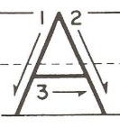 | From the top, diagonally down to the left, up to the top, diagonally down to the right. Lift up  and across.
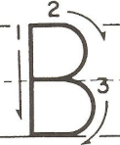 | From the top, down, back to the top. Round to the middle, round to the bottom.
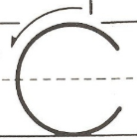 | From the top, curl around to the left to sit on the line.
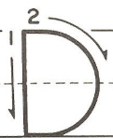 | From the top, down, back to the top. Curve right, down to the bottom.
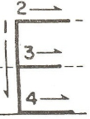 | From the top, down, back to the top. Across, back. Lift up and across the middle. Lift up and  across the bottom line.
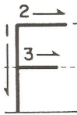 | From the top, down, back to the top. Across, back. Lift up and across the middle.
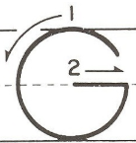 | From the top, curl around to the line, carry on up, then straight down. Lift up and across.
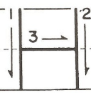 | From the top and down. Space. From the top and down. Lift up and join the lines across the  middle.
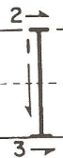 | From the top to the bottom and stop, the across the top and repeat below.
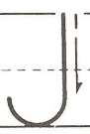 | From the top, all the way down, then short curl to the left.
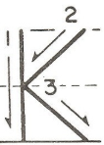 | From the top, down, up to the middle. Diagonally up, back and diagonally down to the line.
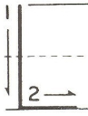 | From the top, down and across the line.
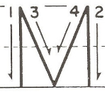 | From the top, down, back to the top. Diagonally down, diagonally up. Straight down to the line.
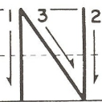 | From the top, down, back to the top. Diagonally down, then straight up to the top.
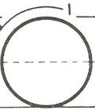 | From the top – all around the o.
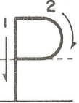 | From the top, down then back up. Curve right to halfway down.
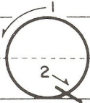 | From the top – all around the o. Lift off. Short line diagonally down.
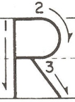 | From the top, down, then back up. Curve right to halfway down. Diagonally down to the line.
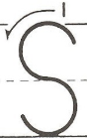 | From the top, under the snake’s chin, slide down and round its tail.
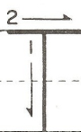 | From the top, down and stop. Lift up and from the left, make a line across the top.
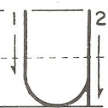 | From the top, down and curve right, then straight up to the top
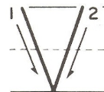 | From the top diagonally right to the bottom, then diagonally up to the top.
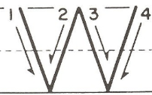 | From the top diagonally right to the bottom, diagonally up to the top, diagonally down to the line, then diagonally up again.
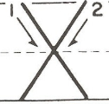 | From the top, diagonally right to the bottom. Space. Start at the top, then diagonally left to the  bottom.
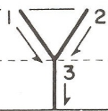 | From the top diagonally right to the middle. Space. From the top diagonally left to the middle.  Straight down to the bottom.
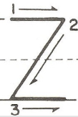 | From the top go across, diagonally down to the left and across the bottom.

.

