Our Lady of the Wayside letter formation
Mnemonic | Grapheme | Formation phrase
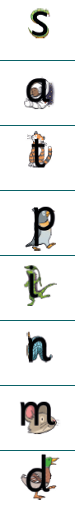 | S | Down the slithering snake.
 | a | Around the astronaut’s helmet.
 | t | Down the tiger and across its neck.
 | p | Down the penguin’s back, up and around.
 | i | Down the iguana and dot the leaf.
 | n | Down, up and over the net.
 | m | Down, up and over and up and over again.
 | d | Around the duck’s body, up to its head and down to its feet.
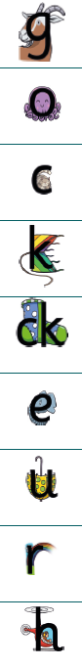 | g | Around the goat’s face and curl under its chin.
 | o | All around the octopus.
 | c | Curl around the cat.
 | k | Down the kite up to the middle, kick and flick.
 | ck | Curl around the cat  Down the kite up to the middle, kick and flick.
 | e | Around the elephant’s eye and curl down its trunk.
 | u | Down and around the umbrella and back down to the ground.
 | r | From the cloud to the ground and over the rainbow.
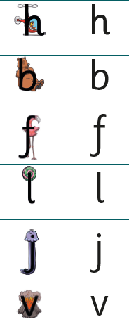  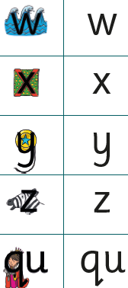 | h | Down, up and over the helicopter.
 | b | Down the bear’s back, up and around its tummy.
 | f | Down the flamingo to its foot and across its wings.
 | l | Down the lollipop stick.
 | j | Down the jellyfish and dot its head.
 | v | Down to the bottom of the volcano and back up to the top.
 | w | Down and up and down and up the waves.
 | x | Criss cross
 | y | Down, around the yo-yo and curl around the string.
 | z | Across the top of the zebra’s head, zig-zag down its neck and along.
 | qu | Around the queen’s face, down low and flick.  Down and around the umbrella and back down to the ground.



