Subject Area | Learning Focus | Useful links (All links are external so please check them carefully before sharing with children )
Writing   | WRITING TO RECOUNT EVENTS: Writing a diary entry in the voice of April – the main character in The Last Bear.  WRITING TO PERSUADE:  Persuasive speech – Saving endangered animals. Non-Fiction Red Alert! Catherine Barr  WRITING TO NARRATE: Write an adventure story, creating a new adventure for Lila on her quest. Based on the book The Firework maker’s daughter.  WRITING TO DESCRIBE Write a Character description based on a character from The Firework maker’s daughter. | https://www.onceuponapicture.co.uk/
Reading  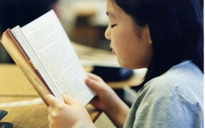 | MODELLED READER:  The Last Bear – Hannah Gold  Red Alert – Lonely Planet Kids  The Firework Makers Daughter – Philip Pullman | https://www.storyberries.com/bedtime-stories-the-easter-bunny-school-easter-stories-for-kids/
Maths   | MULTIPLICATION AND DIVISION: Mental and written methods for multiplication and division. Multiplying and dividing by 10 and 100 (Incl decimals)  FRACTIONS: recognising fractions, writing fractions and finding a fraction of an amount.  TIME: Convert between analogue to digital and 12 and 24 hour clock  GEOMETRY: Shape. Position and direction.  TIMES TABLES: Increasing fluency and recall for multiplication and division facts. | https://mathsframe.co.uk/en/resources/resource/477/Multiplication-Tables-Check  https://www.timestables.co.uk/
Science   | MATTER MATTERS: Compare and group materials together, according to whether they are solids, liquids or gases. Observe that some materials change state when they are heated or cooled, and measure or research the temperature at which this happens in degrees Celsius  Identify the part played by evaporation and condensation in the water cycle and associate the rate of evaporation with temperature.  ON THE INSIDE: Describe the simple functions of the basic parts of the digestive system in humans.  Identify the different types of teeth in humans and their simple functions. | Year 4: Sound | STEM  States of matter - Year 4 Science - BBC Bitesize  What is the digestive system? – KS2 Science curriculum - BBC Bitesize
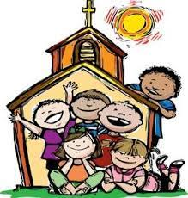  RE | JESUS THE LIGHT OF THE WORLD: Children study some important stories about the life of Jesus and the revelation of his presence in the world. They will also learn about some of the symbols of Baptism and their association with belonging to the Family of God.  LENT: In this unit the children will explore some of the customs and practices associated with the celebration of the Season of Lent. Through the life and teaching of Christ they will learn about prayer, fasting and almsgiving and the forgiveness that God offers to those who believe in him.  HOLY WEEK: Children develop their knowledge and understanding of the story of Christ’s passion and death. They will be given opportunities to reflect upon the circumstances and reasons for his death.  VIRTUES: Curious and Active. Intentional and Prophetic | https://cafod.org.uk/education/for-families  https://www.loyolapress.com
Geography   | ENTER THE RAINFOREST: Children find out about climate zones and the Amazon Rainforest and where the World’s tropical rainforests are found. They discover the settlements I the Amazon and what is happening to the world’s rainforest and how people can help to reduce deforestation. They learn about different biomes and their climate, vegetation, animals and location. | What is a rainforest habitat? - BBC Bitesize
History   | FULL STEAM AHEAD -Our focus is on The Victorians and the Industrial Revolution including history of the local area. They discover how Birmingham grew during the Victorian period and what it was like to work in a factory in Victorian times. They discover the daily life of a Victorian child and look at Victorian houses and living conditions. They look at the legacy of the Victorian period on Birmingham and Britain. | The Industrial Revolution - BBC Bitesize
Music  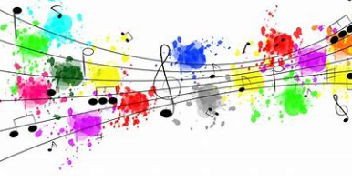 | Get set for Music ANCIENT CHINA; Focus on pitch and reading and writing notation. Children learn about the pentatonic scale and harmonious sounds through composing, performing and singing. This is inspired thought ancient Chinese music, philosophy myths and rituals  SAMBA: Focuses on rhythm and pulse. The children will have the opportunity to perform samba music. They will explore the instruments of the samba and create their own samba band. | https://www.daspmusic.co.uk/ks2-10-15-min-sings.html
ART/D&T  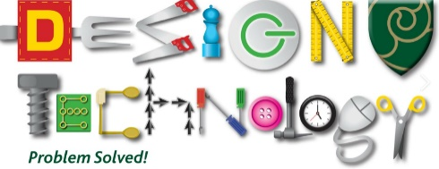   | Painting and mixed media: Light and dark Children will describe the difference between a tint and a shade. Mix tints and shades by adding black or white paint. Discuss their real-life experiences of how colours can appear different. Use tints and shades to paint an object in 3D. Try different arrangements of objects for a composition, explaining their decisions. Produce a clear sketch that reflects the arrangement of their objects. Create a final painting that shows an understanding of how colour can be used to show light and dark and therefore show three dimensions. Paint with care and control to make a still life with recognisable objects.  D&T –ADAPTING A RECIPE: Children will consider the process involved in designing a biscuit. Starting from taste testing existing biscuits, making comparisons, making biscuits, evaluating their bake, considering how to budget and finally designing a biscuit and packaging.
PSHE   | TENTEN:  What am I feeling?  What am I looking at?  I am thoughtful.  Lifestyles  A time for everything  Big changes, little changes
COMPUTING   | Online safety  Computing Systems and Networks  Programming: Further Coding with Scratch
FRENCH:   | PORTRAITS- DESCRIBING IN FRENCH  Understand that adjectives change depending on whether they are describing a boy or girl.  Identify a person correctly from a description of their hair and eye colour.  Place word cards in the correct order, with the adjectives following the noun.  Compose a spoken sentence to describe a friend.  Write four sentences accurately with the correct adjectival agreement, helped by a support sheet.  FRENCH NUMBERS: CALENDARS AND BIRTHDAYS  Say the numbers to 31 in French. Read and calculate Maths sums correctly in French. Say all the days of the week, working out the words for the days that are yesterday and today. Match most of the French months to their English equivalents. Ask when someone’s birthday is and give the number and month of their own birthday. Say the seasons of the year. Translate the date from English to French.  Say the similarities and differences between birthdays in the UK and France.
PE AND GAMES   | GET SET FOR PE  Yoga  Handball  Cricket  Tennis  Swimming

