Subject Area |  | Learning Focus | Useful links (All links are external so please check them carefully before sharing with children )
Writing  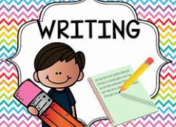 |  | Hansel and Gretal  Real Experience Videos / interview linked to climate change. Writing to explain Explanation text linked to climate change. | https://www.bbc.co.uk/bitesize/topics/zpccwmn  https://www.literacyshed.com/
Reading  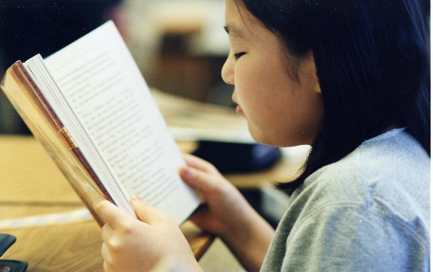 |  | Through a range of reading materials, children consolidate their comprehension skills. | https://www.bbc.co.uk/bitesize/topics/zs44jxs  https://www.literacyshed.com/
Maths   |  | Geometry- position and direction including translations, coordinates, properties of shape and Angles. Algebra – Understanding use of symbols and letters to solve mathematical problems. Measurement- Calculating area and perimeter using knowledge of shape properties. Also Capacity, length and Mass. | https://www.mymaths.co.uk/  https://thirdspacelearning.com/primary-resources/  https://www.ncetm.org.uk/
Science   |  | Material Transformations: | Circuit Construction Kit: DC - Series Circuit | Parallel Circuit | Ohm's Law - PhET Interactive Simulations  Electricity - KS2 Science - BBC Bitesize
  -- Know that some materials will dissolve in liquids to form a solution, and describe how to recover a substance from a solution
  - Use knowledge of solids, liquids and gases to decide how mixtures might be separated, including through evaporation
  - Demonstrate that dissolving, mixing and changes of state are reversible changes
  - Explain that some changes result in the formation of new materials, and that this kind of change is not usually reversible, including changes associated with burning and the action of acid on bicarbonate of soda.
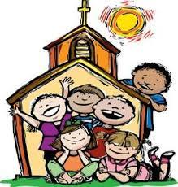  RE |  | Christmas- In this unit of work the children will explore the story of the birth of Christ from the Gospel of St. Matthew and the Gospel of St. Luke. They will also learn about some images of Christ that are found in the Prologue to the Gospel of St. John.  Baptism and Confirmation-In this unit the children will learn about the celebration of the Sacraments of Baptism and Confirmation. They will explore the signs and symbols of both these Sacraments and will hear about the gift of the Holy Spirit being given in the celebration of these Sacraments. | https://cafod.org.uk/education/primary-teaching-resources/advent-calendar-for-children  https://missiontogether.org.uk/calendar/advent-resources/
Geography  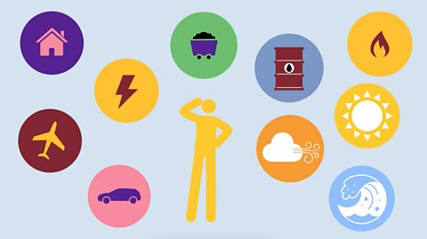 |  | - The Climate Challenge-  - What is climate change?  - How is human activity causing climate change?  - How is climate change affecting the United Kingdom?  - How is climate change affecting life in polar settlements such as Nunavut?  - What are governments and famous people doing to tackle climate change?  How can we help reduce global warming | https://www.bbc.co.uk/bitesize/articles/zcjk7v4#z8mj6rd
Computing  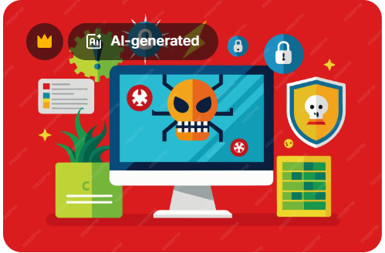 |  | Big Data 1- Handling data  - Explain why barcodes and QR codes were created.  - Follow a QR code treasure trail.  - Explain how infrared can be used to transmit data.  - Explain how RFID works.  - Recall the use of RFID chips.  - Describe real-world uses of RFID.  - Input data and type formulas into a spreadsheet.  - Independently sort and analyse spreadsheet data to conclude customer scenarios. | https://www.bbc.co.uk/bitesize/subjects/zvnrq6f  https://www.stem.org.uk/primary/resources/collections/co
ART/D&T     |  | - Drawing Expressing Ideas  - Identify key features of street art and murals.  - Discuss the intention and impact of street art.  - Use various shading techniques to show texture, tone, form and depth.  - Apply one point perspective in their work.  - Enlarge a drawing by scaling using an accurately drawn grid.  - Show an understanding of perspective, scale and proportion with a level of accuracy across their design.  - Choose appropriate materials for their design and explain their choices and intention.  - Use space effectively to enhance visual impact of their graffiti tag.
PE   |  | Gymnastics  The children will develop their straddle, forward and backwards rolls and put these into a sequence. They will use counterbalance and counter tension in routines and they will develop their jumps and explore the effects of height and they will safely travel over and across apparatus.  Fitness  The children will take part in a range of activities that explore and develop different areas of their health and fitness. They will increase their speed and stamina, develop their strength using their own body weight, they will develop their agility and coordination and develop their balance skills with increasing control.

