Subject Area |  | Learning Focus | Useful links (All links are external so please check them carefully before sharing with children )
Writing  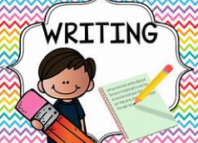 |  | Alma  Writing to narrate. Suspense story telling the events of the film.  Writing to recount- Journalistic.  Journalistic recount of the disappearing children. | https://www.bbc.co.uk/bitesize/topics/zpccwmn  https://www.literacyshed.com/
Reading  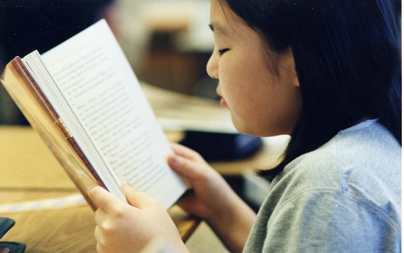 |  | Through a range of reading materials, children consolidate their comprehension skills. | https://www.bbc.co.uk/bitesize/topics/zs44jxs  https://www.literacyshed.com/
Maths   |  | Geometry- position and direction including translations, coordinates, properties of shape and 3D shape. Data handling- bar charts, line graphs, conversion graphs and pie charts | https://www.mymaths.co.uk/  https://thirdspacelearning.com/primary-resources/  https://www.ncetm.org.uk/
Science   |  | The game of Survival: | https://www.bbc.co.uk/bitesize/topics/zvhhvcw  https://www.bbc.co.uk/teach/class-clips-video/articles/z92xtrd  https://www.stem.org.uk/resources/library/collection/12648/year-6-evolution-and-inheritance  https://www.thenational.academy/teachers/programmes/science-primary-ks2/units/evolution-and-inheritance/lessons
  Recognise that living things have changed over time and that fossils provide information about living things that inhabited the Earth millions of years ago
  - Recognise that living things produce offspring of the same kind, but normally offspring vary and are not identical to their parents
  - Identify how animals and plants are adapted to suit their environment in different ways and that adaptation may lead to evolution.
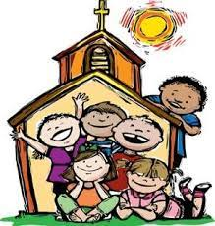  RE |  | Lent-  children will know about the Church’s customs for the Season of Lent. They will understand some reasons why Jesus spoke of prayer, fasting and almsgiving being important and be able to think about applying these in their own lives. The children will be able to discuss issues concerning poverty in the world today and think about some remedies for this problem. The children will know  that the Scriptures speak of God’s mercy and forgiveness and they will understand how the Church celebrates this in the Sacrament of Reconciliation.  Holy week-  children will know the story of the passion of Jesus in some detail. They will be able to imagine some of the thoughts and feelings of Jesus in the Garden of Gethsemane and think of some reasons why Peter denied Jesus. They will know some words of Jesus from the cross and understand why the death of Jesus has been described as a sacrifice. | https://cafod.org.uk/education/primary-teaching-resources/advent-calendar-for-children  https://missiontogether.org.uk/calendar/advent-resources/
Geography   |  | - The Climate Challenge-  - What is climate change?  - How is human activity causing climate change?  - How is climate change affecting the United Kingdom?  - How is climate change affecting life in polar settlements such as Nunavut?  - What are governments and famous people doing to tackle climate change?  How can we help reduce global warming | https://www.bbc.co.uk/bitesize/articles/zcjk7v4#z8mj6rd
RSE |  | Using Tenten resource  Part 1:  Gifts and talents  Spots and sleep  Body Image  Peculiar feelings  Emotional changes
ART/D&T  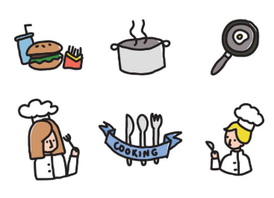 |  | Come Dine with me-  What makes an effective recipe? Where and how are ingredients grown, reared, caught and processed? What is seasonality? What does starter, main and dessert mean? What is the farm to fork process? How is a healthy and varied diet achieved?  I can research and design a three course meal I can list the ingredients, method and equipment needed for a chosen recipe I can follow a recipe and use the correct quantities of each ingredient I can write a recipe, explaining the process taken I can use culinary skills and knowledge effectively I can contribute an attractive and easily understood recipe page to a class cookbook using imperative verbs, adjectives and illustrations I can develop a design criteria for my course and evaluate my course against it | https://www.thenational.academy/teachers/programmes/design-technology-primary-ks2-l/units/cooking-and-nutrition-healthy-and-varied-diets-ec15/lessons  https://www.stem.org.uk/resources/library/collection/466479/ks2-cooking-and-nutrition  https://www.bbc.co.uk/bitesize/topics/z63nrmn
PE |  | Hockey:  Physical dribble, pass receive, tackle, intercept, shoot, balance, jump.  Social communication- collaboration, respect and support others.  Emotional perseverance- honesty, fair play and determination.  Rounders:  Physical throw, catch, bowl, bat, field and run.  Social communication- collaboration, respect and communication  Emotional perseverance- honesty, self-regulation and sportsmanship.

