Subject Area |  | Learning Focus | Useful links (All links are external so please check them carefully before sharing with children )
Writing  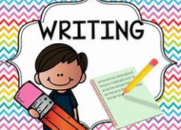 |  | Consolidate SPAG and reading skills in preparation for sats  Writing- Non Fiction- Linked to our history topic- The Windrush Generation.  Journalistic writing- recount of the arrival of the Windrush  Poetry- Free verse poetry linked to the Windrush Generation. | https://www.bbc.co.uk/bitesize/topics/zpccwmn  https://www.literacyshed.com/
Reading  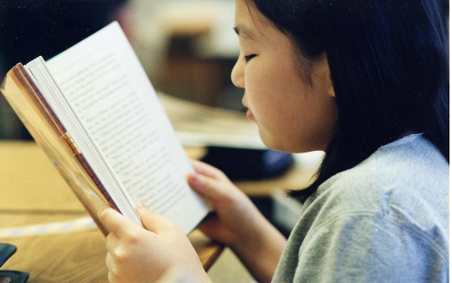 |  | Through a range of reading materials, children consolidate their comprehension skills. | https://www.bbc.co.uk/bitesize/topics/zs44jxs  https://www.literacyshed.com/
Maths   |  | Geometry- position and direction including translations, coordinates, properties of shape and 3D shape. Data handling- bar charts, line graphs, conversion graphs and pie charts | https://www.mymaths.co.uk/  https://thirdspacelearning.com/primary-resources/  https://www.ncetm.org.uk/
Science   |  | The game of Survival: | https://www.bbc.co.uk/bitesize/topics/zvhhvcw  https://www.bbc.co.uk/teach/class-clips-video/articles/z92xtrd  https://www.stem.org.uk/resources/library/collection/12648/year-6-evolution-and-inheritance  https://www.thenational.academy/teachers/programmes/science-primary-ks2/units/evolution-and-inheritance/lessons
  Recognise that living things have changed over time and that fossils provide information about living things that inhabited the Earth millions of years ago
  - Recognise that living things produce offspring of the same kind, but normally offspring vary and are not identical to their parents
  - Identify how animals and plants are adapted to suit their environment in different ways and that adaptation may lead to evolution.
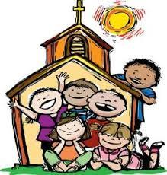  RE |  | Easter In this unit the children study the story of Easter from the perspective of Thomas. The work contained in this unit will require them to think about reasons why Thomas did not believe in the Resurrection of Christ at first and why people today believe that Jesus is risen from the dead. Children will also learn about Easter and the promise of eternal life.  They will be introduced to some associations with Baptism and the celebration of a Christian funeral.  Pentecost-In this unit the children will learn about two stories from the New Testament about the coming of the Holy Spirit.  Through their study of the Sacrament of Confirmation they will learn about the Gifts and Fruits of the Holy Spirit and how they are important in the lives of Christians. | https://cafod.org.uk/education/primary-teaching-resources/advent-calendar-for-children  https://missiontogether.org.uk/calendar/advent-resources/
History   |  | The Windrush Generation  Why did the Windrush Generation come to Britain?  Who wee the Windrush Generation?  What was life like when they arrived?  Where did they settle?  Why is Floella Benjamin significant?  The legacy on Britain of the Windrush Generation | https://www.bbc.co.uk/bitesize/articles/zcjk7v4#z8mj6rd
RSE  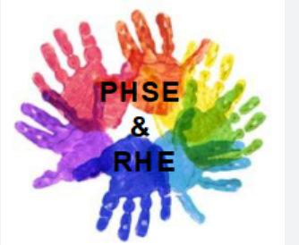 |  | Using Tenten resource  Part 1: Continued  Peculiar feelings  Emotional changes  PSHE:  Transition to secondary school
ART/D&T  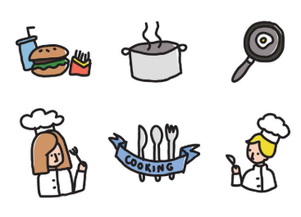 |  | D&T:  What makes an effective recipe? Where and how are ingredients grown, reared, caught and processed? What is seasonality? What does starter, main and dessert mean? What is the farm to fork process? How is a healthy and varied diet achieved?  Healthy foods and importance of packaging and ingredients clearly labelled showing energy and fats in foods.  Children bake and cook from a range of recipes.  Art: Sculpture and 3D- making memories  - Create expressively in their own personal style and in response to their choice of stimulus, showing the ability to develop artwork independently.  - Combine materials and techniques appropriate to fit with ideas.  - Work in a sustained way over several sessions to complete a piece, including working collaboratively on a larger scale and incorporating the formal elements of art. | https://www.thenational.academy/teachers/programmes/design-technology-primary-ks2-l/units/cooking-and-nutrition-healthy-and-varied-diets-ec15/lessons  https://www.stem.org.uk/resources/library/collection/466479/ks2-cooking-and-nutrition  https://www.bbc.co.uk/bitesize/topics/z63nrmn
PE |  | Rounders- Learning the rules of the game whilst developing batting and bowling techniques.  Athletics- Preparing for sports day including sprinting and relay running, throwing techniques and high jump.

