Subject Area |  | Learning Focus | Useful links (All links are external so please check them carefully before sharing with children )
Writing  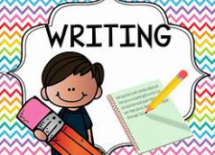 |  | WRITING TO DESCRIBE: This half-term, we will be writing a setting description of the Sky People’s village from the text ‘The rabbit who stole the fire.’  WRITING TO RECOUNT: We will be writing a diary entry from the point of view of the rabbit from the text ‘The rabbit who stole the fire.’. | https://www.onceuponapicture.co.uk/
Reading  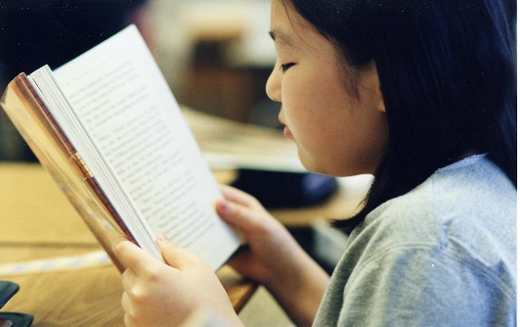 |  | PHONICS: This half-term, we’ll be continuing with Little Wandle’s Year 2 Spelling scheme of learning  PROSODY: We’ll be practising and improving our fluency and expression when reading aloud.  COMPREHENSION: We will be continuing the comprehension style of learning promoting oracy.  MODELLED READERS: The rabbit who stole the fire by Joanna Troughton | https://www.storyberries.com/bedtime-stories-the-easter-bunny-school-easter-stories-for-kids/
Maths   |  | FRACTIONS: We will be focusing on recognising and finding ½ ¼ and 1/3 of objects, amounts and length  TIME: Know the number of minutes in an hour/ number of hours in a day. Compare and sequence intervals of time. Tell and write the time to five minutes, including quarter past/to the hour.  POSITION DIRECTION: Order/  arrange combinations of mathematical objects in patterns /sequences.  Use mathematical vocabulary to describe position, direction and movement, including movement in a straight line and distinguishing between rotation as a turn.  MULTIPLICATION/ DIVISION: We’ll be practising our 10 X, 2 X and 5 X tables to help us remember multiplication and division facts. | https://ttrockstars.com/  https://mathsframe.co.uk/en/resources/resource/477/Multiplication-Tables-Check  https://www.timestables.co.uk/  https://firstlook.educationcity.com/content/Activity/index/25812
Science   |  | LET’S GROW – We will learn about the structure of bulbs and seeds. We will discover which temperature is the best for germination and will also observe changes in our bulb over time as it starts to germinate. | https://www.stem.org.uk/resources/community/collection/12723/year-2-living-things-and-their-habitats
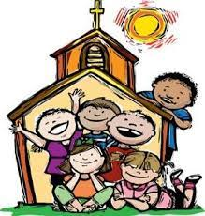  RE |  | EASTER: The children will develop their knowledge and understanding of the stories of Easter from the New  Testament and of the symbols the Church uses to celebrate the Season.  PENTECOST: We will revisit the story of Pentecost and of the activity and presence of the Holy Spirit. We will also focus on the way Pentecost is celebrated in the Church and Confirmation being the Sacrament of the Holy Spirit.
History  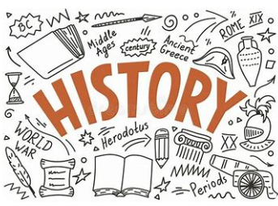 |  | BOURNEVILLE: We will be finding out Who George Cadbury was and why is he significant. What the houses in Bournville were like. How Bournville improved life for factory workers and the legacy of George Cadbury and Bournville.  We will also go on a trip to Cadbury World to support our learning!
Music   |  | FOUR SEASONS: Using the music of Vivaldi’s ‘The Four Seasons’ we will be focusing on pulse, dynamics, tempo, rhythm and pitch through performance, improvision and composition activities. | https://www.daspmusic.co.uk/ks2-10-15-min-sings.html
ART/D&T  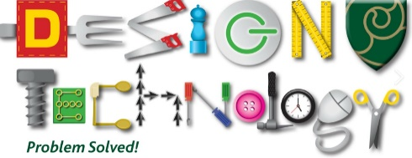   |  | DT – FABRIC POUCHES: This half term we will be sewing our own fabric pouches. Children will start by designing a pouch to make. They will then practice using a template to cut the fabric and will learn how to do a running stich. Finally, children will make their finished product, adding decoration and then evaluating it.
PE / Games  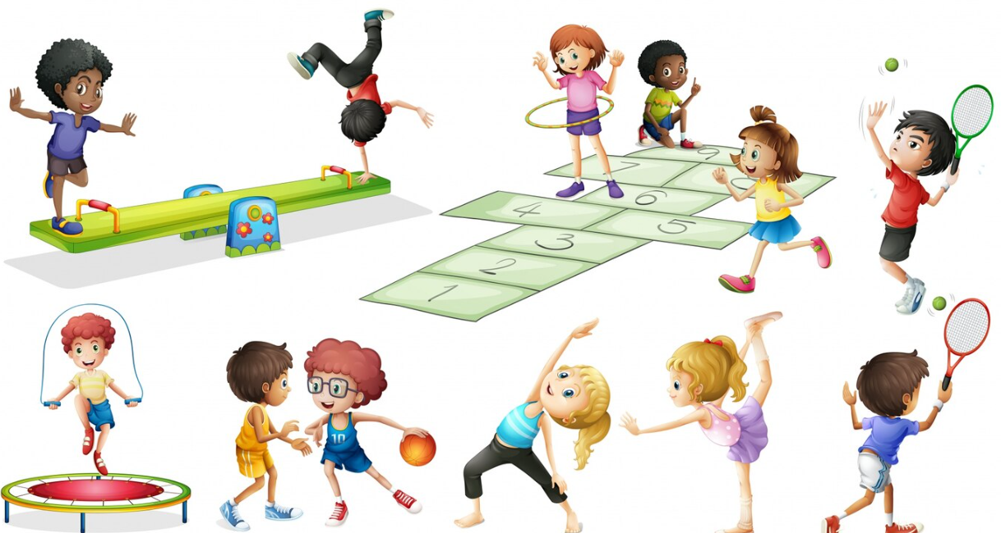 |  | PE - DANCE: children will experiment with different movements. Learning to count a beat and move in time to the music.  GAMES - ATHLETICS: We will develop skills used in athletics such as running at different speeds, jumping and throwing.

