Subject Area | Learning Focus | Useful links (All links are external so please check them carefully before sharing with children )
Writing  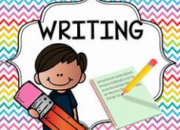 | - Writing to recount events –Focus text Billy and the Beast by Nadia Shireen. Children will write a recount from the view of the character Billy.  - Writing to narrate. Focus text Mr. Benn. Children will write their own Mr Benn story.  - Writing to describe- Focus text The Twits by Roald Dahl. Children will write a character description of Mr and Mrs Twit.  - Writing to instruct – Focus text The Twits by Roald Dahl.  Children will write instructions for worm spaghetti. | https://www.onceuponapicture.co.uk/  SPAG  KS1 English - BBC Bitesize
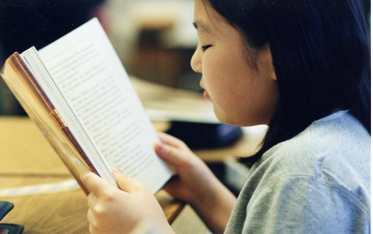  Reading | - Billy and the Beast by Nadia Shireen  - Mr Benn  - The Twits – Roald Dahl  - Dirty Bertie David Roberts  - Cops and Robbers Allan Ahlberg  - Pumpkin Soup Helen Cooper  - The ugly five Julia Donaldson  - It Kate Milner  - My name is not Refugee Kate Milner  - Milo Tom Percival  - Tilda’s Tries Again Tom Percival;  Wigglesworth Bottom Primary the Magic Hamster Pamela Butchart | Bedtime Stories, Done Beautifully | Bedtime Stories
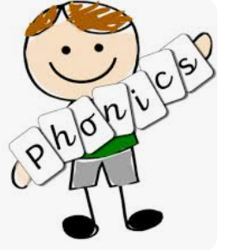  Phonics | Little Wandle  Summer 1 Weeks 1-6  Week 1 /ay/ play, /a_e/ shake, /ea/ each, /e/ he  Week 2 /ie/ pie, /i_e/ time, /o/ go, /o_e/ home  Week 3 /ue/ blue, rescue, /ew/ chew, new, /u_e/ rude, cute, /aw/ claw  Week 4 /ea/ head, /ir/ bird, /ou/ cloud, /oy/ toy  Week 5 /i/ tiger, /a/ paper, /ow/ snow, /u/ unicorn  Week 6 /ph/ phone, /wh/ wheel, /ie/ shield, /g/ giant  No new tricky words this term  Summer 2 Weeks 1- 5  Week 1 /ai/ /eigh/ /aigh/ /ey/ /ea/ eight, straight, grey, break  /n/ /kn/ /gn/ knee, gnaw  /m/ /mb/ thumb  /ear/ /ere/ /eer/ here, deer  Tricky words: busy, beautiful, pretty, hour  Week 2 /zh/ /su/ /si/ treasure, vision  /j/ /dge/ bridge  /i/ /y/ crystal  /j/ ge large  Tricky words – move, improve, parents, shoe  Week 3 /sh/ /ti/ /ssi/ /si/ /ci/ mission, mansion, delicious  Week 4 /or/ /augh/ /our/ /ore/ daughter, pour, oar, more  Week 5 - Review | For parents | Letters and Sounds
Maths  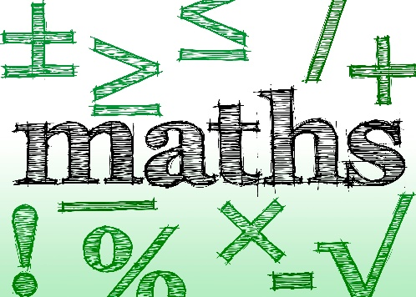 | Multiplication and Division  - Count in 2s, 5s and 10s  - Recognise and make equal groups  - Add equal groups using repeated addition  - Make arrays  - Share equally (grouping and sharing)  - Solve simple multiplication and division problems  Fractions  - Recognise and find half of a shape or quantity  - Recognise and find a quarter of a shape or quantity  - Understand fractions as equal parts of a whole  Position and Direction  - Describe position (left, right, above, below, between)  - Use ordinal numbers (first, second, third, etc.)  - Describe turns (quarter turn, half turn, three-quarter turn, full turn)  - Use language such as clockwise and anticlockwise  Place Value (within 100)  - Count from 50 to 100 and beyond  - Count in tens to 100  - Partition numbers into tens and ones  - Compare numbers using greater than, less than, equal to  - Order numbers within 100  - Identify one more and one less  Money  - Recognise coins and notes  - Count in coins (1p, 2p, 5p, 10p, etc.)  - Make the same amount using different coins  - Compare amounts of money  - Solve simple problems involving money  Time  - Tell the time to the hour  - Tell the time to half past the hour  - Sequence events in chronological order  - Use language such as before, after, next, yesterday, today, tomorrow  Daily NCTEM Mastery of Maths | Key Stage 1 Maths - Topmarks Search  ictgames || html5 Home Page  mathsframe.co.uk/en/resources/category/22/most-popular  KS1 Maths - BBC Bitesize  Crickweb | Welcome to Crickweb  Numberblocks - BBC iPlayer
Science  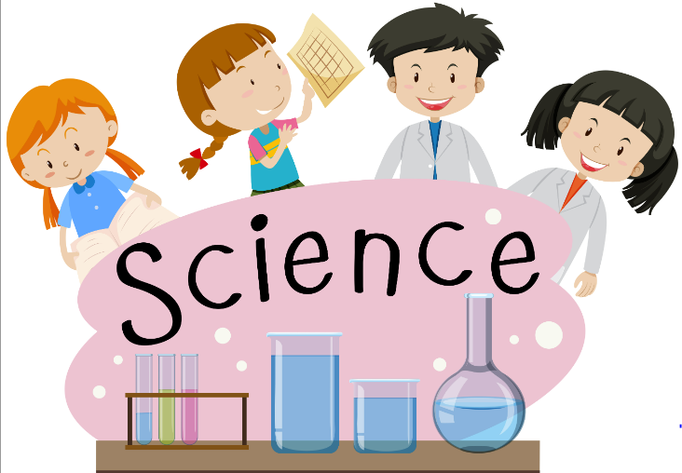 | Marvellous materials  - There are different materials such as wood, plastic, glass and metal.  - • All objects are made from one or more materials.  - • Some materials are natural and others are made by humans.  - • Natural materials are materials that are found in nature such as wood.  - • Human-made materials are materials that are made by humans such as plastic.  - • Words that describe materials are called “properties”.  - • Properties of materials include hard, soft, shiny, dull, rough, smooth, waterproof, not waterproof, opaque and transparent.  - • Materials can be grouped using their properties.  • Some materials can be recycled to make new objects  Plant Detectives  There are lots of different types of plants including daisies, poppies, roses and sunflowers.  • Weeds are wild plants that grow in places that people do not want them to grow, such as nettles.  • Some plants are flowering plants and some plants do not flower.  • Flowering plants have roots, a stem, leaves and a flower with petals.  • Plants need water, light, soil and a suitable place to grow.  • Trees are a type of plant and have roots, a trunk, branches, leaves and flowers.  • Deciduous trees such as oak trees and sycamore trees drop their leaves during Autumn and grow new leaves during Spring.  • Evergreen trees such as pine trees keep their leaves all year.  • Some plants are safe for humans to eat including apples, carrots and beans. | Geography | KS1 | KS2 | The seasons | BBC Teach  Time Lapse of the Changing Seasons | BBC Teach  It's All About Time - Why Do Seasons Change | Get Set Galactic | CBeebies  How Plants Grow | KS1 Science Year 2 | Home Learning - YouTube  Science | KS1 | The plant life cycle | BBC Teach  Animals including humans - KS1 Science - BBC Bitesize  Animals: KS1 Science resources - BBC Teach  Everyday materials - KS1 Science - BBC Bitesize  Bitesize Daily: 5-7 Year Olds - Science 5-6 Year-Olds: 5. Everyday Materials - BBC iPlayer  Testing the strength of different materials | BBC Teach  Year 1: Everyday Materials | STEM
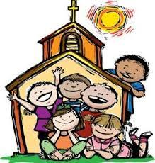  RE | - Easter  - Pentecost  - Following Jesus today.  - Sharing Jesus’ life  Virtues  - Grateful and Generous  Attentive and Discerning | 🌿🐰🐣The Story of Easter - The Beginners Bible - YouTube  God Sends the Holy Spirit
History  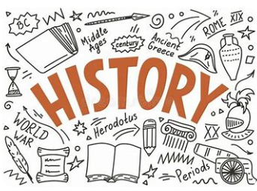 | Castle Life  • Castles were built on hills to protect people and to show power.  • Castles had towers, battlements, thick stone walls and sometimes a moat.  • Most castles had a great hall, a kitchen, chambers and stables.  • A king, queen, lord or lady was in charge of a castle.  • Lots of other people lived and worked in castles doing jobs such as cooks, blacksmiths, soldiers and servants and a priest.  • Entertainment in castles  included banquets, jousting, jesters and falconry. | https://youtu.be/iKdQDX2OEpw  Travel and transport | KS1 topics | BBC Teach  Bessie Coleman | 3 Minute History Cartoon  Go Jetters - Series 3: 10. Go Jetter Heroes: Amelia Earhart - BBC iPlayer  History KS2 | Explorers: Amelia Earhart | BBC Teach  The Wright Brothers, First Successful Airplane (1903)
Geography  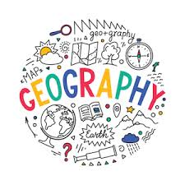 | World Explorers:  • England is a country in the continent of Europe.  • Indonesia is a country in the continent of Asia and is a hotter country than England.  • Greenland is a country in the continent of North America and is a colder country than England. | What are human and physical features in geography? - BBC Bitesize  How to understand geographical fieldwork - BBC Bitesize  My local area - BBC Bitesize
Music   | Fantasy and Adventure  - To listen to music and make comparisons  - To create and perform from written symbols with an awareness of pitch  - To create and perform from written symbols with an awareness of pitch  - To respond to music showing an awareness of pitch, dynamics and tempo.  - To explore stick notation with a good awareness of a steady pulse.  - To compose and perform a piece of music that tells a story.  At the Seaside  - To compose a sequence of sounds to create music.  - To be able to follow a visual score.  - To choose symbols to compose and perform a score.  - To play keeping a steady pulse.  - To use symbols to compose, record and perform sounds on a score.  - To use symbols to structure and perform a score keeping a steady pulse. | What are pulse and rhythm in music? - BBC Bitesize  Vocal warm up - BBC Bitesize  Play it!, Music - BBC Bitesize - Primary Games - BBC Bitesize
ART/D&T  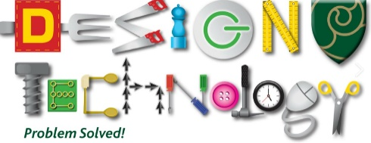   | D&T Puppets  - To join fabrics together using different methods.  - To use a template to create my design.  - To join two fabrics together accurately.  - To embellish my design using joining methods.  Art – Craft and design: Woven wonders  - To know that art can be made in different ways.  - To choose, measure, arrange and fix materials.  - To explore plaiting, threading and knotting techniques.  - To learn how to weave.  To combine techniques in a woven artwork. | What is a wheel and axle mechanism? - KS1 - BBC Bitesize  What is a wheel and axle mechanism? - KS1 - BBC Bitesize
PE  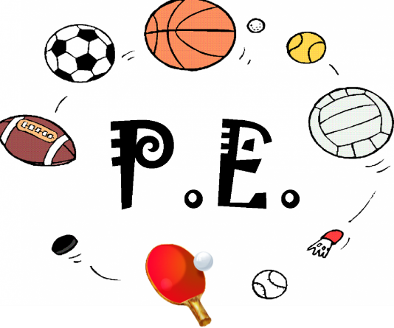 | Dance  - To explore travelling movements.  - To develop and combine travelling movements.  - To develop quality when performing and linking shapes.  - To develop quality when linking shapes.  - To develop stability and control when performing balances.  - To develop stability and control when performing balances.  - To develop technique and control when performing shape jumps.  - To develop technique and control when performing shape jumps.  - To develop technique in the barrel, straight and forward roll.  - To develop rolls and use them in a sequence.  - To link gymnastic actions to create a sequence.  - To develop quality in gymnastics sequences.  Athletics  In this unit pupils will develop skills required in athletic activities such as running at different speeds, changing direction, jumping and throwing. In all athletic based activities, pupils will engage in performing skills and measuring performance, competing to improve on their own score and against others. They are given opportunities to work collaboratively as well as independently.  Physical – run, balance, agility, co-ordination, hop, jump, leap, throw.  Social - work safely, collaboration  Emotional- perseverance, independence, honesty, determination  Thinking – reflection, comprehension, select and apply skills.  Sports Day -Teams try to score in the oppositions goals. Examples are football, rugby, handball, netball, hockey and basketball. Pupils develop their understanding of attacking and defending and what being ‘in possession’ means. They use and develop skills such as sending and receiving with both feet and hands as well as dribbling with both feet and hands. They have the opportunity to play both even and uneven sided games, They learn how to score points and how to play by the rules  Skills -Physical – dribble, throw catch. Kick, receive run jump change direction and speed.  Social – supporting others, co-operation, communication and kindness  Emotional – perseverance, honesty, confidence  Thinking – comprehension, identify strength and areas for development, select and apply  Net and Wall games – There are 2 teams. One the batting team trying to score points and one the fielding team trying to stop them from scoring. Examples are cricket and rounders. Children develop their understanding of the principle of defending and attacking for striking and fielding games.  Skills – Underarm and overarm throw, track, catch, bat. Communication, collaboration, support and encourage others, kindness. Honesty and perseverance. Use tactics, select and apply, decision making. | 5-a-day Fitness: Pirate Sing-Along  Mindful Monday Yoga - KS1 Mike the monkey  Reach For The Stars: Yoga Club (Week 8) | Cosmic Kids  Physical Education KS1 / KS2: Let's Get Active - BBC Teach  PE at Home for KS1 & Foundation - Ball Skills (youtube.com)
Computing   | Programming – Bee-Bots  - To explore a new device.  - To create a demonstration video.  - To plan and follow a precise set of instructions.  - To program a device.  - To create a program that tells a story. | Keeping safe online - BBC Bitesize  Take a minute - Safer Internet Day 2018 film for 3-7 year olds  Bee-Bot Online Emulator
RHE  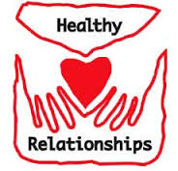 | Module Two: Created to Love Others explores the understanding that we have been created out of the love and for love, this Module explores how we take this calling into our family, friendships and relationships, and teaches strategies from developing healthy relationships and keeping safe both online and in our daily lives. | Jessie Friends videos
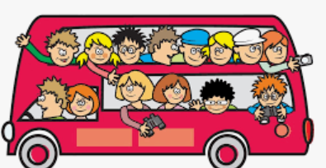  Trips and Visits | Kenilworth Castle -  Forest School – Bills Wood – outdoor learning, 6 week programme.

