Subject Area | Learning Focus | Useful links  (All links are external so please check them carefully before sharing with children )
Writing  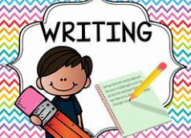 | WRITING TO DESCRIBE: We will start the year with our modern story, ‘The Koala Who Could.’ Children will write a character description about Kevin the Koala.  WRITING TO INFORM: Our non-fiction unit will use the wonderful Big Book of Blue as a writing stimulus for a non-chronological report.  WRITING TO NARRATE: Children will re-tell the story the Elves and the Shoe Maker. | https://www.onceuponapicture.co.uk/  https://www.youtube.com/watch?v=VcdVsRfUbjk
Reading  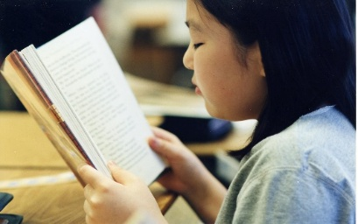 | PHONICS: This half-term, we’ll be continuing with Little Wandle as taught in Year 1.  PROSODY: We’ll be practising and improving our fluency and expression when reading aloud.  COMPREHENSION: We’ll be exploring a range of texts and applying our rapidly-developing comprehension skills to better understand them.  MODELLED READERS: Iron Man by Ted Hughes and ‘The Hodgeheg’ by Dick King-Smith | https://www.storyberries.com/bedtime-stories-the-easter-bunny-school-easter-stories-for-kids/
Maths  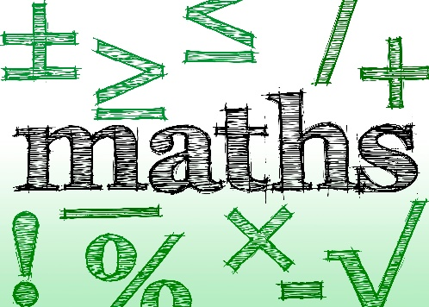 | Using the maths mastery approach pupils will learn…  Place Value  Addition and Subtraction | https://mathsframe.co.uk/en/resources/resource/477/Multiplication-Tables-Check  https://www.timestables.co.uk/  https://firstlook.educationcity.com/content/Activity/index/25812  TTRS Times Tables Rock Stars: Play
  1 | Pupils explain that one ten is equivalent to ten ones
  2 | Pupils represent multiples of ten using their numerals
  3 | Pupils represent multiples of ten using their numerals and names
  4 | Pupils represent multiples of ten in an expression or an equation
  5 | Pupils estimate the position of multiples of ten on a 0-100 number line
  6 | Pupils explain what happens when you add and subtract ten to a multiple of ten
  7 | Pupils use knowledge of facts and unitising to add and subtract multiples of ten
  8 | Pupils add and subtract multiples of ten
  9 | Pupils explore the counting sequence for counting to 100 and beyond
  10 | Pupils count a large group of objects by counting groups of tens and the extra ones
  11 | Pupils count a large group of objects by using knowledge of unitising by counting tens and ones
  12 | Pupils represent a number from 20-99 in different ways
  13 | Pupils explain and mark the position of numbers 20-99 on a number line
  14 | Pupils explain that numbers 20-99 can be represented as a length
  15 | Pupils compare two, two-digit numbers
  16 | Pupils partition a two-digit number into tens and ones
  17 | Pupils add two, two-digit numbers by partitioning into tens and one
  1 | Pupils add three addends
  2 | Pupils use a ‘First... Then… Now” story to add 3 addends
  3 | Pupils explain that addends can be added in any order
  4 | Pupils add 3 addends efficiently
  5 | Pupils add 3 addends efficiently by finding two addends that total 10
  6 | Pupils add two numbers that bridge through 10
  7 | Pupils subtract two numbers that bridge through 10
  8 | Pupils compare numbers and describe how many more or less there are in each set
  9 | Pupils calculate the difference
  10 | Pupils use knowledge of subtraction to solve problems in a range of contexts
  11 | Pupils explain what the difference is between consecutive numbers
  12 | Pupils calculate difference when information is presented in a pictogram
  13 | Pupils calculate difference when information is presented in a bar chart
Science  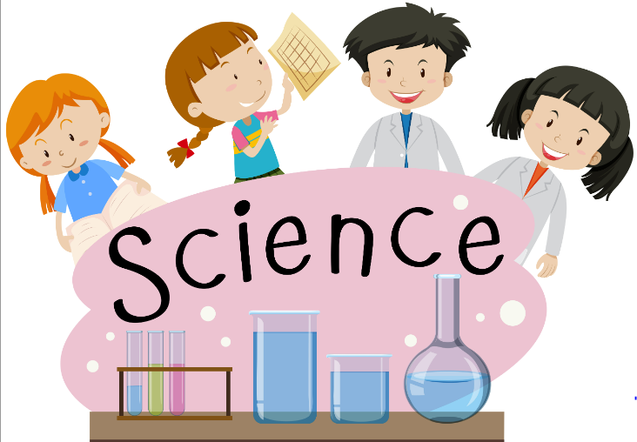 | HABITAT EXPLORERS: | https://www.stem.org.uk/resources/community/collection/12723/year-2-living-things-and-their-habitats
  Things are either alive, dead or have never been alive.
  Living things need food, water, air, space to move and grow, and some shelter to survive.
  A habitat is a natural environment or home of a variety of plants and animals.
  Habitats provide food, water, air, space to move and grow, and some shelter to the plants and animals that live there.
  There are different habitats in the UK such as woodlands, rivers, ponds, rockpools and hedgerows.
  Other habitats around the world are desert, rainforest, ocean and polar.
  A microhabitat is a very small habitat, such as under stones in grass, under leaves and in soil.
  Minibeasts such as worms, snails, spiders and woodlice often live in microhabitats.
  Animals and plants need each other to survive.
  A food chain is the sequence of the plants and animals that are eaten by other animals.
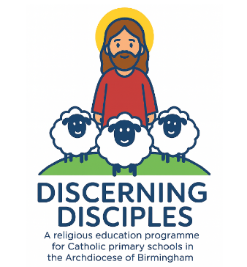  RE | BRANCH 1: CREATION AND COVENANT  The Old Testament and The New Testament.  Noah’s Ark  Stewardship  Baptism  Psalms | https://www.youtube.com/@SaddlebackKids
History  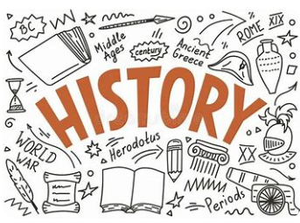 | WONDERFUL WHEELS: This half-term we’ll be learning about changes in bikes and cars. We will use our historical skills of:    Developing and understanding chronology,    Using and interpreting historical sources,   Explaining historical reasons   Comparing and contrasting. | https://www.bbc.co.uk/teach/class-clips-video/articles/zyp4kty
Music  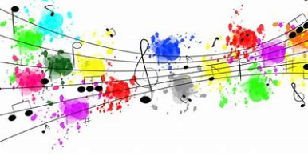 | GLOCKENSPIEL: Children will build on learning from last year, reading notation and playing the glockenspiel. You will be able to join us for our end of unit show, later in the Autumn Term. | https://www.daspmusic.co.uk/ks2-10-15-min-sings.html
ART/D&T  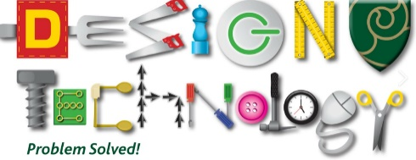   | ART – DRAWING: Understanding tone and texture: In this unit pupils will be exploring how artists use tone and texture, applying these techniques in observational drawings.  D&T – BABY BEARS CHAIR: In this unit children will learn how to make a stable structure. | https://quentinblake.com/
PE / Games  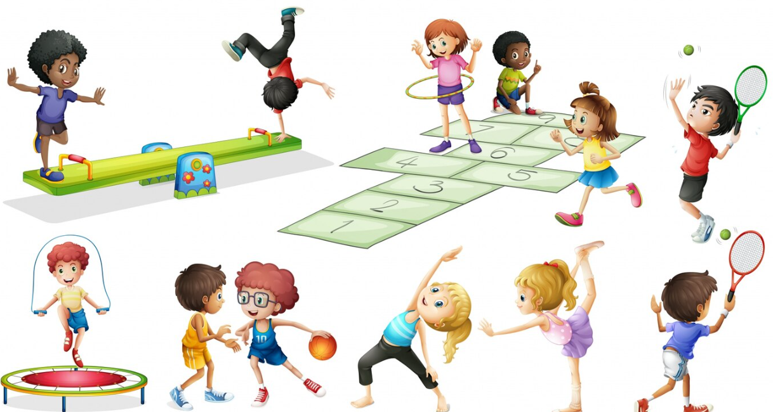 | PE - FUNDAMENTALS: In this unit pupils will develop the fundamental skills of balancing, running, changing direction, jumping, hopping and skipping. Pupils will be given opportunities to work with a range of different equipment. Pupils will be asked to observe and recognise improvements for their own and others' skills and identify areas of strength. Pupils will be given the opportunity to work collaboratively with others, taking turns and sharing ideas.  GAMES – BALL SKILLS: In this unit pupils will develop their fundamental ball skills such as throwing, catching, rolling, hitting a target, dribbling with both hands and feet and kicking. They will look to perform these skills with increasing control and accuracy using co-ordination and balance. Pupils will have the opportunity to work independently, in pairs and small groups.
COMPUTING   | ONLINE SAFETY – We will be teaching children to stay safe online.

