Subject Area | Learning Focus | Useful links (All links are external so please check them carefully before sharing with children )
ENGLISH WRITING  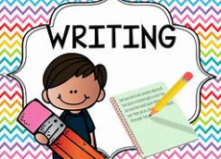 | WRITING TO NARRATE: Writing a story from a different perspective. We are focusing on the folk tale of ‘The bananas belong to the monkeys.’  WRITING TO INFORM: A non-chronological report. We are writing a report focussing on an aspect of the Anglo-Saxon life.  WRITNG TO DESCRIBE – A setting description of the Woleb from the book ‘The Creakers’ by Tom Fletcher  WRITING TO NARRATE _ DIALOGUE – A short conversation between two characters from the Creakers.  POETRY – A selection of Haikus | https://www.onceuponapicture.co.uk/
ENGLISH READING  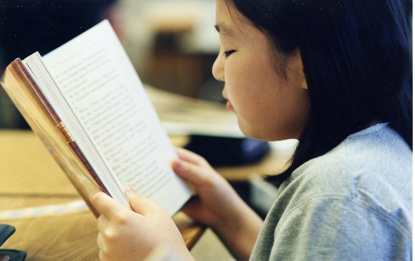 | COMPREHENSION Improving fluency and expression when reading aloud.  Learning key comprehension skills through a variety of texts.  MODELLED READER: Year full of stories – The bananas belong to the monkeys.  The Creakers byTom Fletcher.  All children will read the selection of ‘Grow with a books’ in the class library through the year.  A weekly reading book  A library book of their choice from the school library. | https://www.storyberries.com/bedtime-stories-the-easter-bunny-school-easter-stories-for-kids/
MATHS  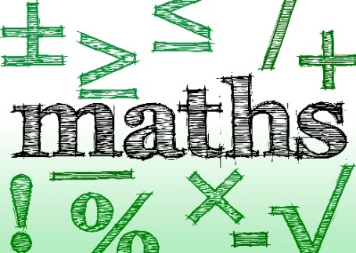 | PLACE VALUE: Value of digits up to 10,000, reading and writing numbers in numerals and words. Rounding numbers  ADDITION and SUBTRACTION: Mental and written methods for addition and subtraction.  TIMES TABLES: Increasing fluency and recall for multiplication and division facts.  MULTIPLICATION & DIVISION | https://mathsframe.co.uk/en/resources/resource/477/Multiplication-Tables-Check  https://www.timestables.co.uk/
SCIENCE  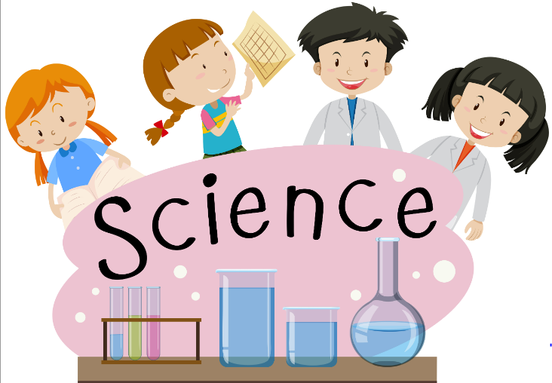 | ENNVIRONMENTAL RANGERS: Classification, food chains, habitats and learning about how humans can have a positive and negative influence on our environment.  ELECTRCITY Identifying common appliances that work on electricity. Constructing a simple series electrical circuit, identifying and naming its basic parts, including cells, wires, bulbs, switches and buzzers. Recognise some common conductors and insulators, and associate metals with being good conductors. Being safe around electricity. Visit from National Grid. | Year 4: Sound | STEM  KS2 Science: How do electrical circuits work? - BBC Teach  Bitesize Daily: 9-11 Year Olds - Science 10-11 Year Olds: 5. Electricity - BBC iPlayer
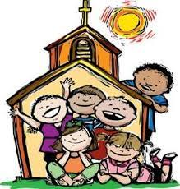  R.E. | CREATION AND CONVENANT  Abraham and his covenant with God  PROPHECY AND PROMISE  Christ the King  The Jesse Tree  Elijah  John the Baptist  Advent a time of preparing our hearts for Jesus  VALUES AND VIRTUES  Compassionate and Loving  Faith filled and hopeful | https://cafod.org.uk/education/for-families  https://www.loyolapress.com
HISTORY  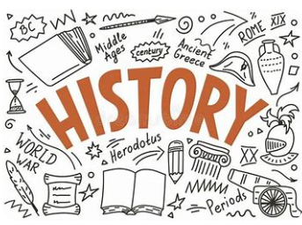 | ANGLO-SAXON SETTLERS: Children will learn who the Anglo-Saxons were, when they began to invade Britain and how they settled over time. Children will learn about the society of the Anglo-Saxons and the legacy they left behind. Children will develop their chronological understanding and vocabulary. | BBC - Search results for Anglo Saxons invade
  GEOGRAP HY | ENTER THE RAINFOREST  Children will be learning all about the climate zones. They will focus on a tropical rainforest biome and look at rainforests their location and why they are important. They will look in detail at the Amazon rainforest and what settlements are there. Finally, they will look at what is happening to the worlds rainforests and how we can help to reduce deforestation. | Tropical rainforest regions of the world - 4th level Geography - Video - BBC Bitesize  Green plants and animals in the rainforest - Living things: Video playlist - BBC Bitesize
MUSIC   | ANCIENT CHINA – Focus on pitch and reading and writing notation inspired thought the exploration of ancient Chinese music, philosophy, myths and rituals.  MINIMALISM – Explore the musical style of minimalism. Children listen and appraise works by key composers of the style | https://www.daspmusic.co.uk/ks2-10-15-min-sings.html
ART/D&T  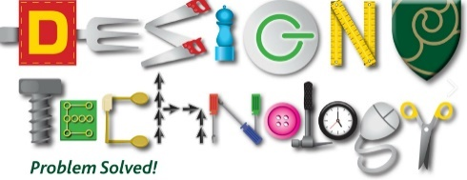   | Art: DRAWING, EXPLORING TONE, TEXTURE AND PROPORTION  Create a three-dimensional effect by using contrasting tones to show light and dark.  Combine lines and marks to represent different textures.  Use lines and marks in different ways to represent dark and light areas (tone).  Comparing the sizes of different objects to draw them in proportion.  Represent the size of one object relative to another.  Consider where to place each element thinking carefully about the space.  Show texture in the collage.  Use the impasto technique to create textured effects  D&T FOOD AND NUTRITION  Design and make a rainforest-inspired cookie for yourself to enjoy.
GAMES / PE   | FITNESS - Children take part in a range of activities that develop different areas of their health and fitness  DANCE – Pupils focus on creating characters and narrative through movement and gesture.  HOCKEY – Pupils develop their understanding of attacking and defending in invasion games  GYMNASTICS – Children develop balance, rolling, jumping and inverted movements and use these skills to develop more complex sequences.  SWIMMING – All children will have 6 week swimming programme across the year
COMPUTING   | ONLINE SAFETY  Describe how to search over multiple platforms and be aware of the accuracy of the results presented.  Describe some of the methods used to persuade people to buy online.  Explain the difference between fact, opinion and belief and recognise these online.  Explain what a bot is and give examples of different bots.  Explain some positive and negative distractions of using technology and small strategies for reducing the time spent on technology
RHE  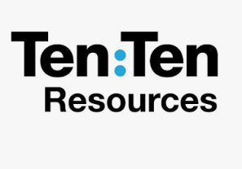 | LIVE LIFE TO THE FULL  Children will learn about characteristics of positive relationships, with particular reference to  friendships, family relationships, and relationships with other children and with adults. This starts with pupils being taught about what a relationship is, what  friendship is, what family means and who the people are who can support them. Pupils should be taught how to take turns, how to treat each other with kindness, consideration and respect, the importance of honesty and truthfulness, permission seeking and giving, and the concept of personal privacy.

